Index
1. Data Quality & Sanity Checks
2. IAM Permissions & Securit

Data Quality & Sanity Check Queries
Partition-Level Aggregation & Volume Check:
SELECT
rate_date,
COUNT(*) AS curated_records_count,
COUNT(DISTINCT target_currency) AS distinct_currency_count,
ROUND(AVG(exchange_rate), 4) AS avg_exchange_rate,
MIN(ingested_at) AS first_ingested_at,
MAX(ingested_at) AS last_ingested_at
FROM `snappy-mapper-498509-e0.analytics_lakehouse.currency_rates_gold`
GROUP BY rate_date
ORDER BY rate_date DESC;
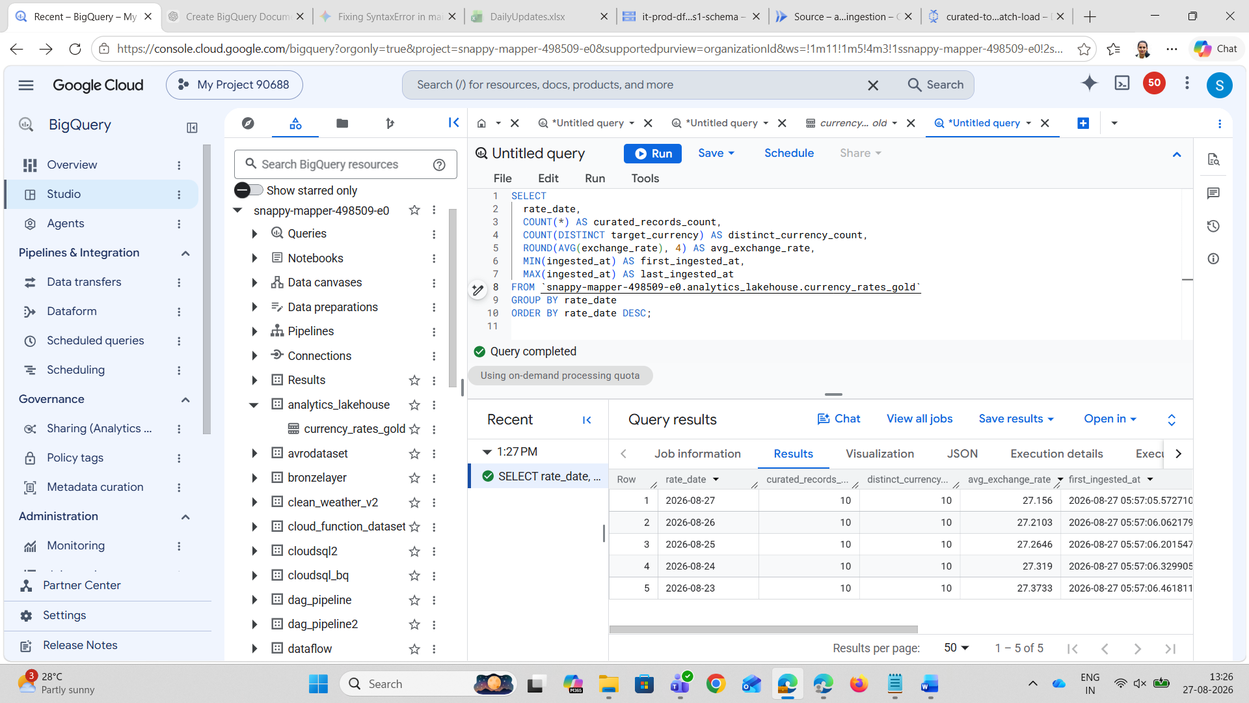

Nullity & Integrity Constraint Check
SELECT
COUNTIF(base_currency IS NULL) AS null_base_curr,
COUNTIF(target_currency IS NULL) AS null_target_curr,
COUNTIF(exchange_rate IS NULL OR exchange_rate <= 0) AS invalid_exchange_rates,
COUNTIF(rate_date IS NULL) AS null_rate_dates,
COUNT(*) AS total_rows
FROM `snappy-mapper-498509-e0.analytics_lakehouse.currency_rates_gold`;
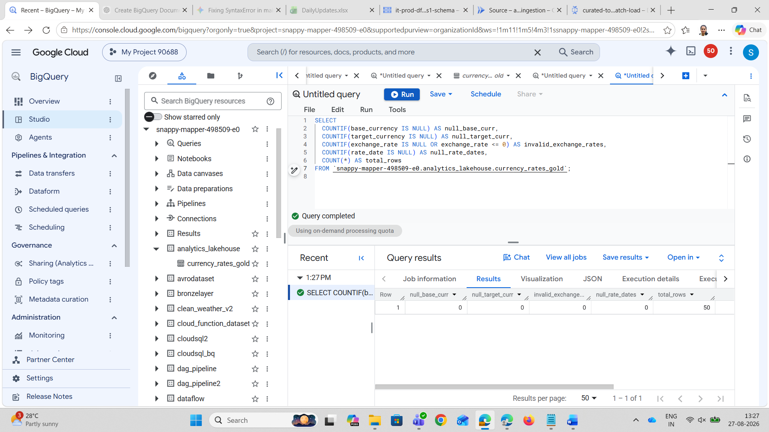

Duplicate Key Detection Check
SELECT
rate_date,
base_currency,
target_currency,
COUNT(*) AS row_count
FROM `snappy-mapper-498509-e0.analytics_lakehouse.currency_rates_gold`
GROUP BY 1, 2, 3
HAVING row_count > 1;

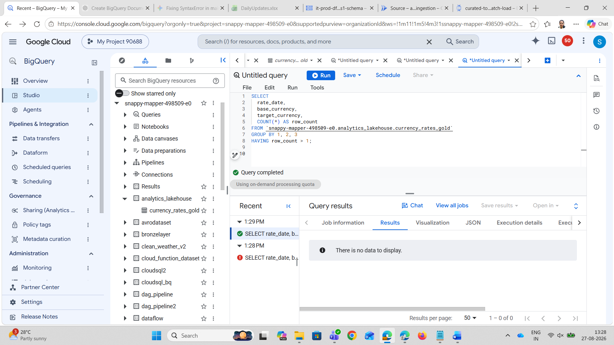

Target Currency Whitelist & Completeness Check
Purpose: Verifies that only the 10 intended ISO currency codes were loaded, and checks if any currency was dropped during ingestion. --- (Expected Result: 0 rows returned)

SELECT
target_currency,
COUNT(*) AS record_count,
MIN(exchange_rate) AS min_rate,
MAX(exchange_rate) AS max_rate
FROM `snappy-mapper-498509-e0.analytics_lakehouse.currency_rates_gold`
WHERE target_currency NOT IN ('EUR', 'INR', 'GBP', 'JPY', 'AUD', 'CAD', 'SGD', 'CHF', 'CNY', 'AED')
OR base_currency != 'USD'
GROUP BY target_currency;
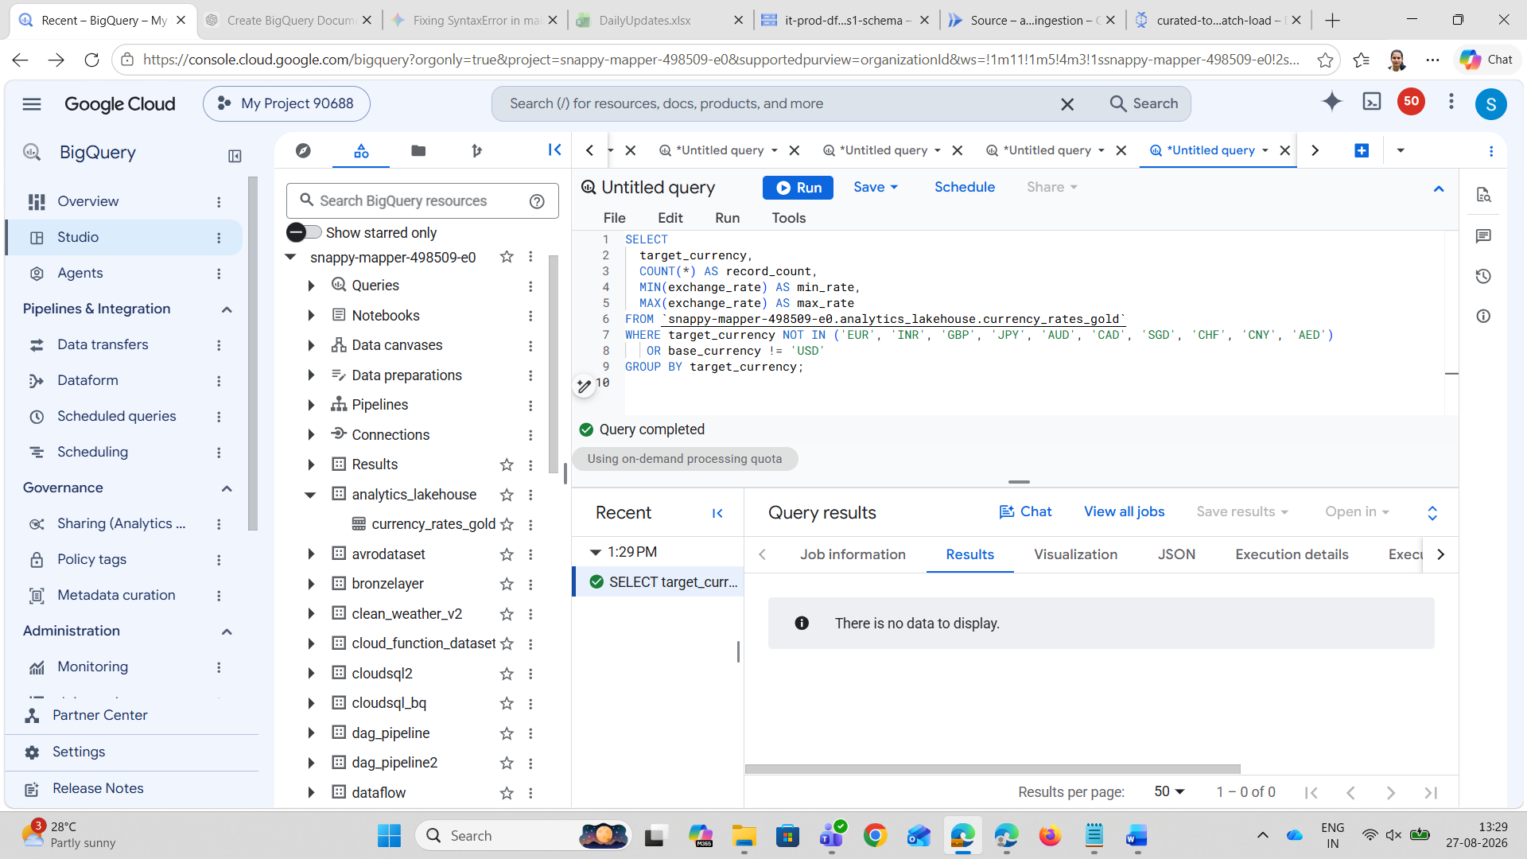

Date Range & Time-Anomaly Validation
Purpose: Ensures there are no future dates, dates outside the 5-day ingestion window, or timestamps where ingestion occurred before the rate date. ---- (Expected Result: All counts equal 0)

SELECT
COUNTIF(rate_date > CURRENT_DATE()) AS future_rate_dates,
COUNTIF(rate_date < DATE_SUB(CURRENT_DATE(), INTERVAL 30 DAY)) AS stale_out_of_range_dates,
COUNTIF(DATE(ingested_at) < rate_date) AS chronological_anomalies
FROM `snappy-mapper-498509-e0.analytics_lakehouse.currency_rates_gold`;
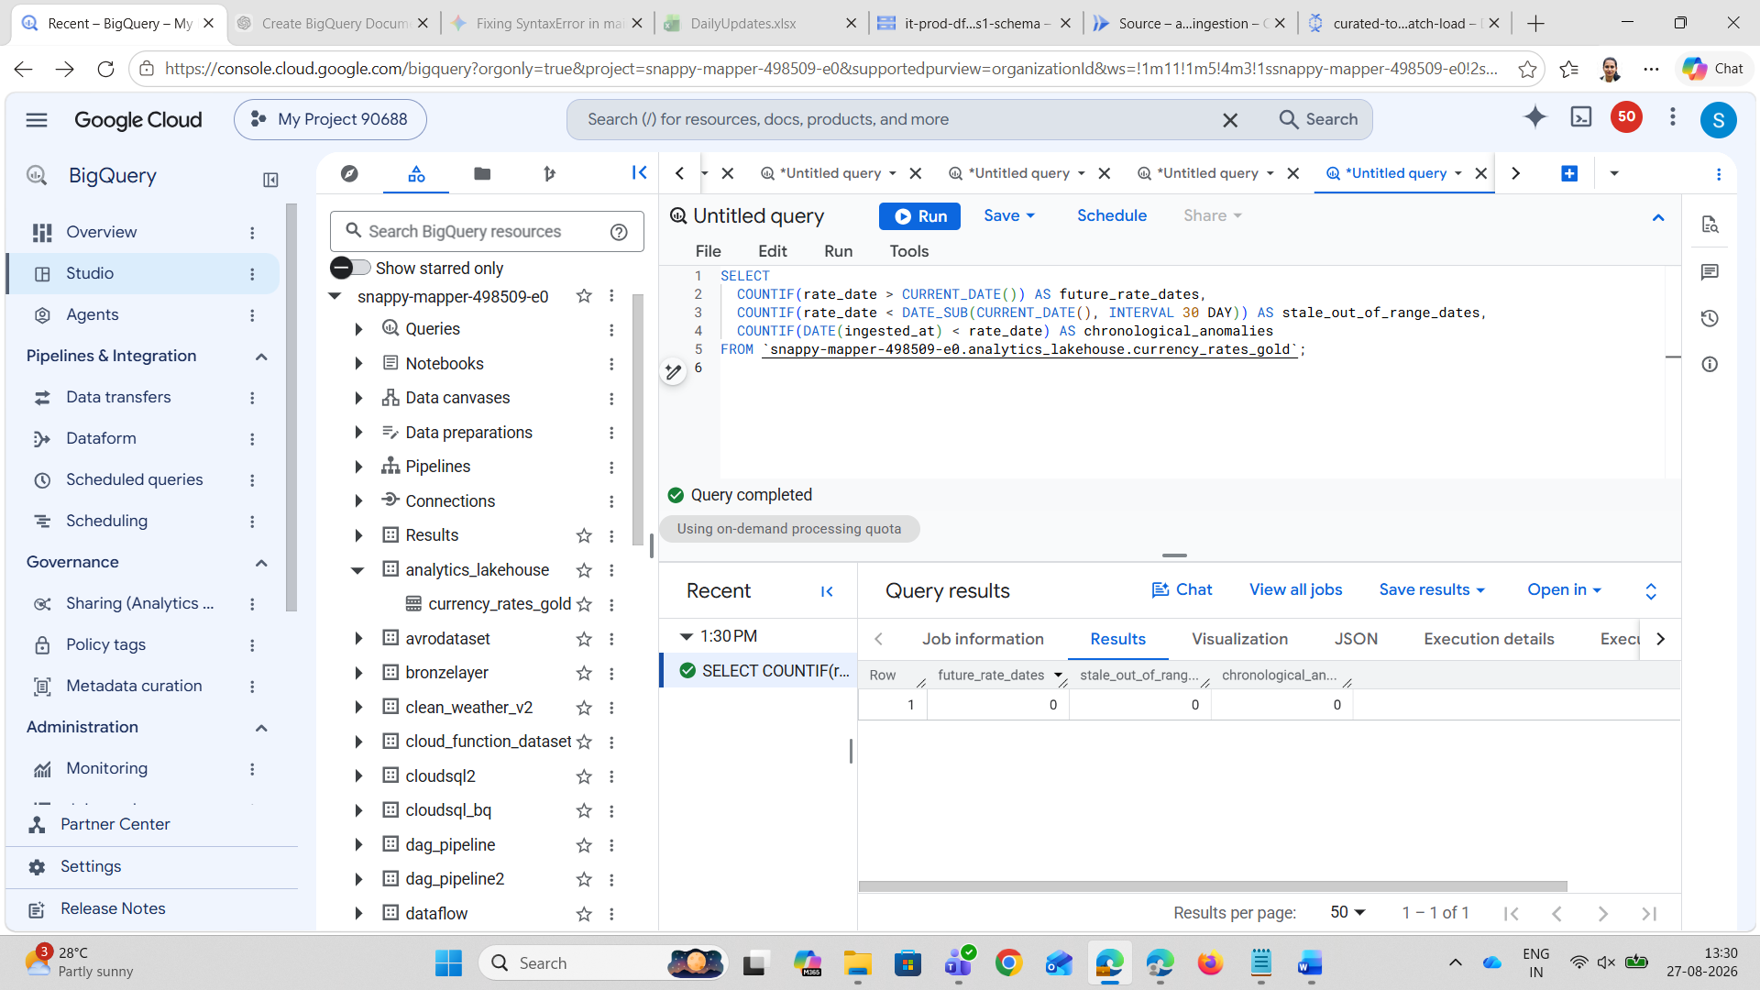

IAM Permissions & Security Architecture
In Google Cloud Platform (GCP), Identity and Access Management (IAM) enforces the principle of least privilege, ensuring services and user accounts are granted only the precise set of permissions necessary to perform their workload.
For this automated ETL pipeline, the default Compute Engine service account (54903645206-compute@developer.gserviceaccount.com) acts as the execution identity for both the Cloud Function and the Dataflow worker instances.
- Storage Object Admin (roles/storage.objectAdmin): Grants read and write access on the Bronze, Silver, and Scratch buckets. Enables Cloud Functions to write JSON/JSONL files and Dataflow to read source files and manage temporary staging objects.
- BigQuery Data Editor (roles/bigquery.dataEditor): Grants write permissions scoped specifically to the analytics_lakehouse dataset so Dataflow can insert records into the currency_rates_gold table.
- BigQuery Job User (roles/bigquery.jobUser): Project-level permission that allows Dataflow to run BigQuery load and insertion jobs.
- Dataflow Worker (roles/dataflow.worker): Grants worker VMs permission to pull tasks, report heartbeats, write logs, and send metrics to Cloud Monitoring.
- Dataflow Admin (roles/dataflow.admin): (For deployer / CI/CD) Allows creating, monitoring, and canceling Dataflow jobs.
- Cloud Functions Invoker (roles/cloudfunctions.invoker): Authorizes scheduled runners (like Cloud Scheduler) to trigger the ingestion function securely over HTTPS.

